ASSIGNMENT-1

HOW TO CREATE WINDOWS INSTANCE:

STEP-1: First go to the AWS account

STEP-2: Next click on EC2 service in that click on launch instance it in orange button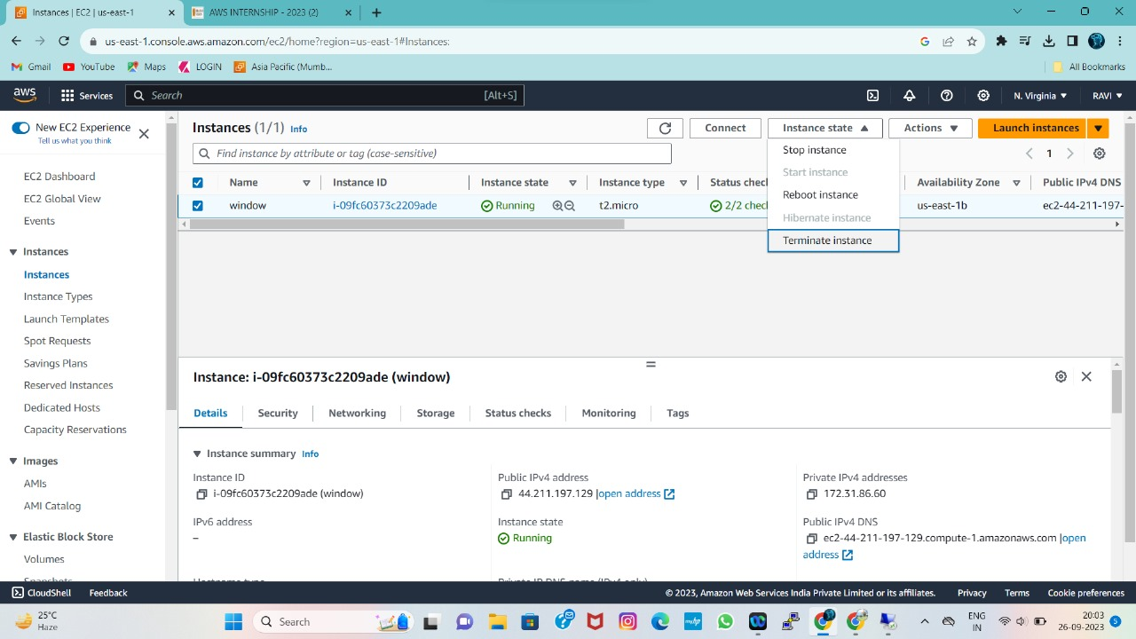

STEP-3: Next it asks enter name and tags then enter windows as show in figure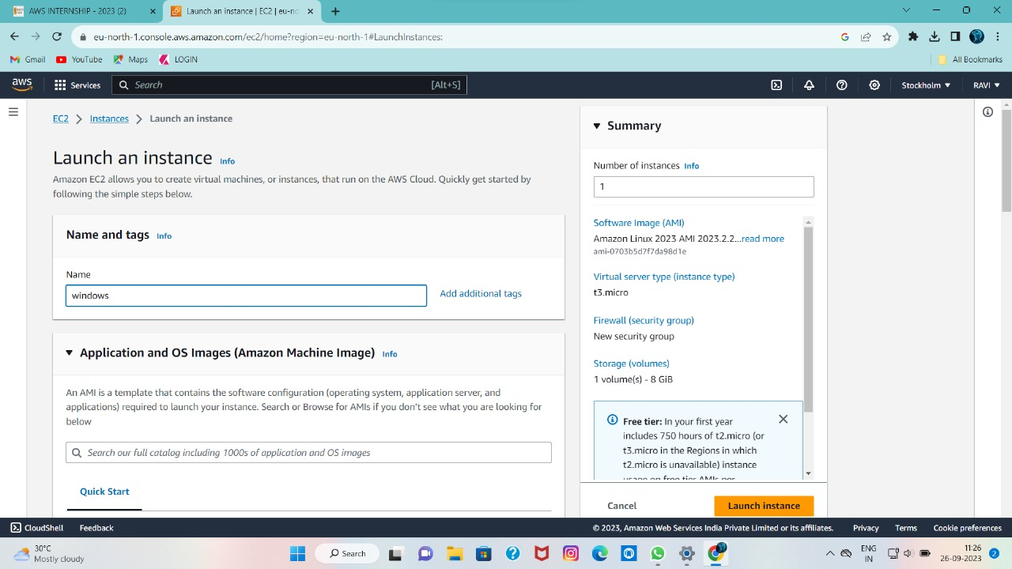

STEP-4: It asks select the operating system (OS) you will must select free trail windows OS.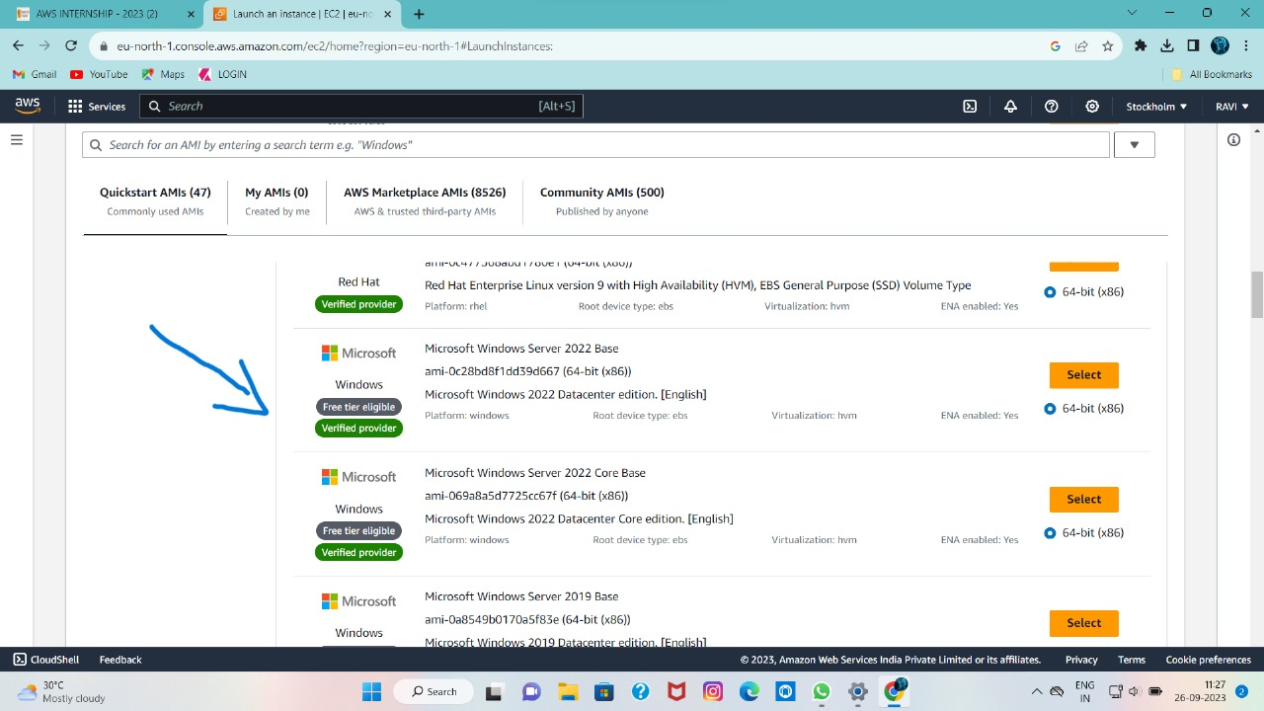

STEP-5: Next there is instant tag it is include with free tire eligible then click on it.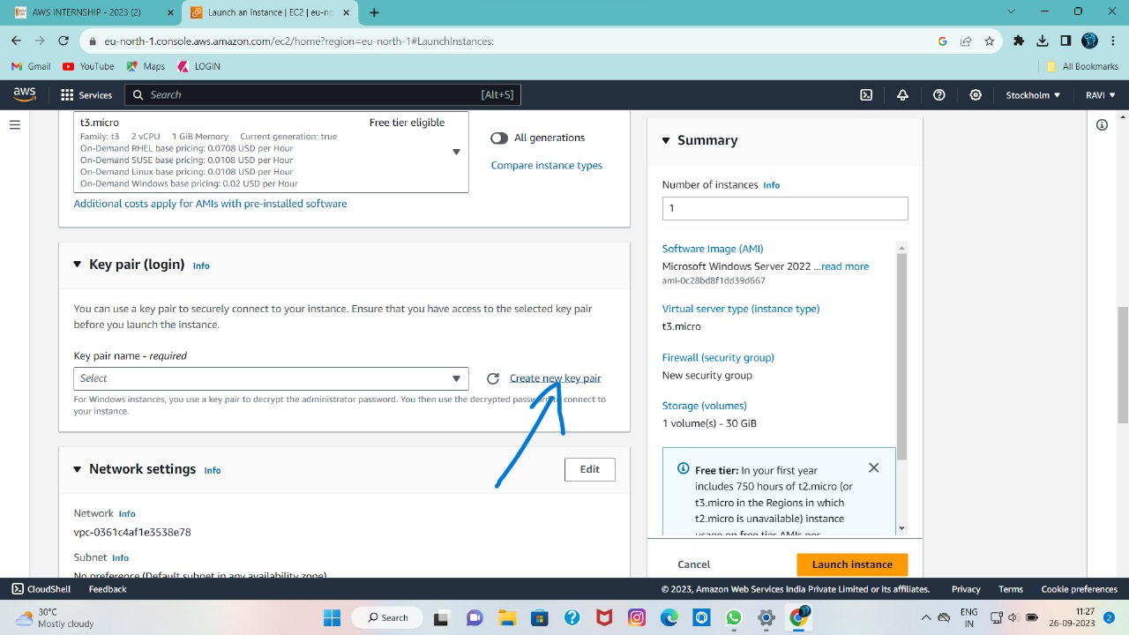

STEP-6: It asks key pair then in that we create a new key pair as show in figure.

STEP-7:Next it ask network settings in that we change security group name with your key pair name and description also.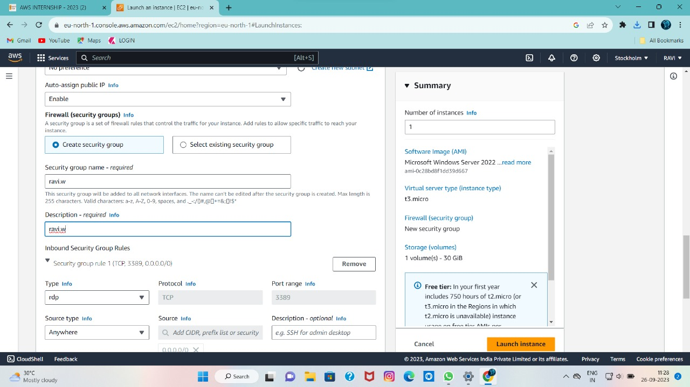

STEP-8: We should maintain security group rule with type=rdp and proto range=3389 and source file is any where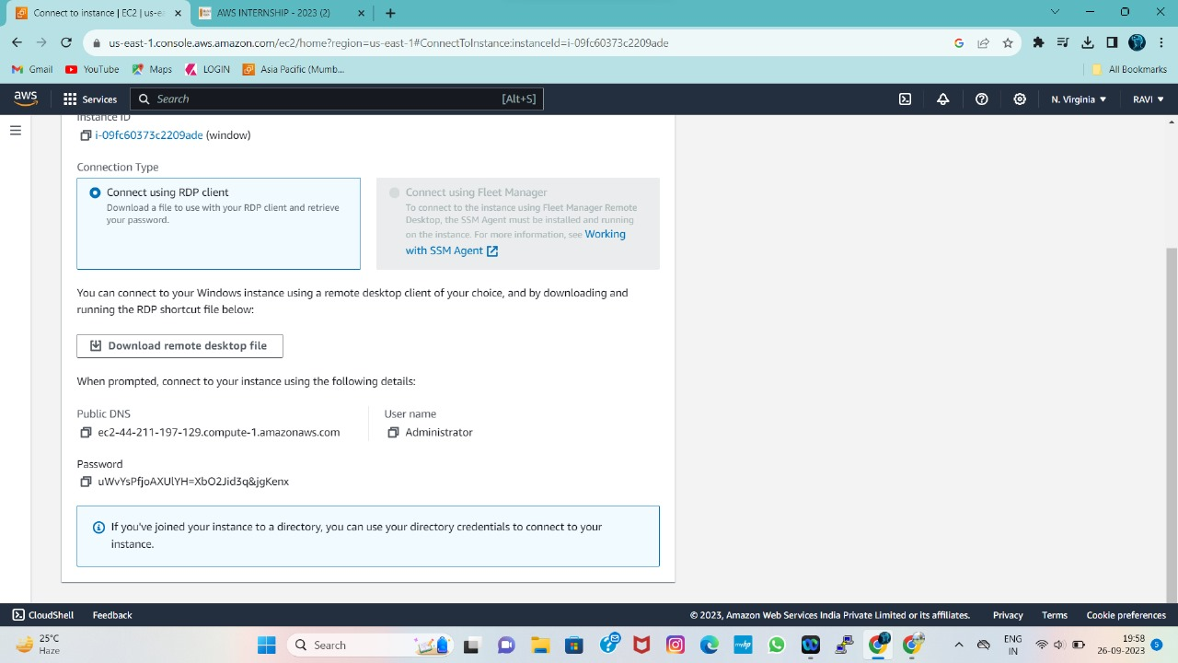

STEP-9: It shows configure storage in free trail customer can get up to 30GB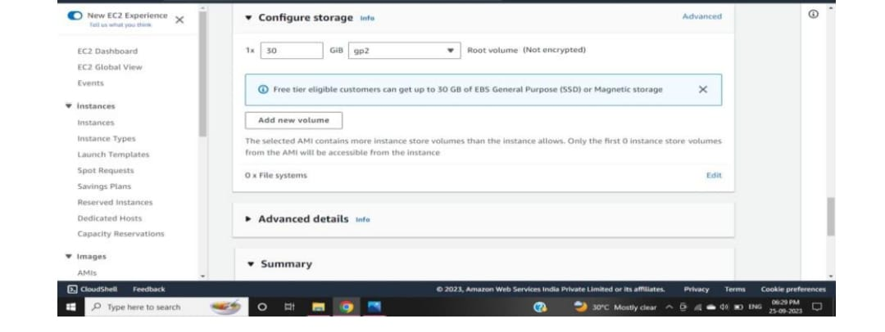

STEP-10: After that we click launch an instance it will show successfully initiated launch of instance and we scroll up click on view all instance.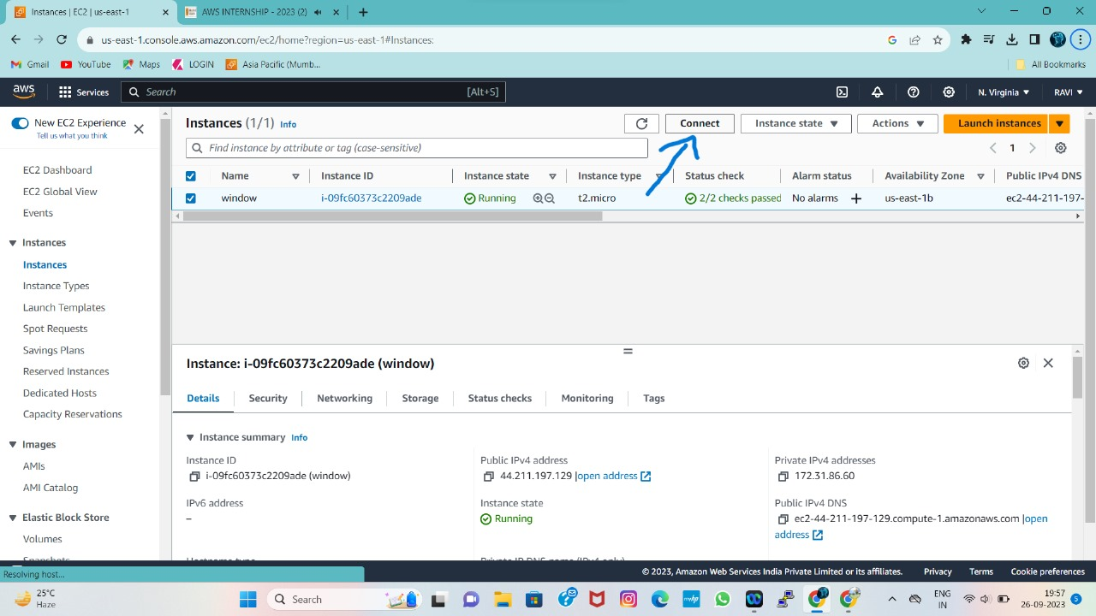

STEP-11: In this step we can covert(.pem) file into password after that we upload private key file then click on decrypt password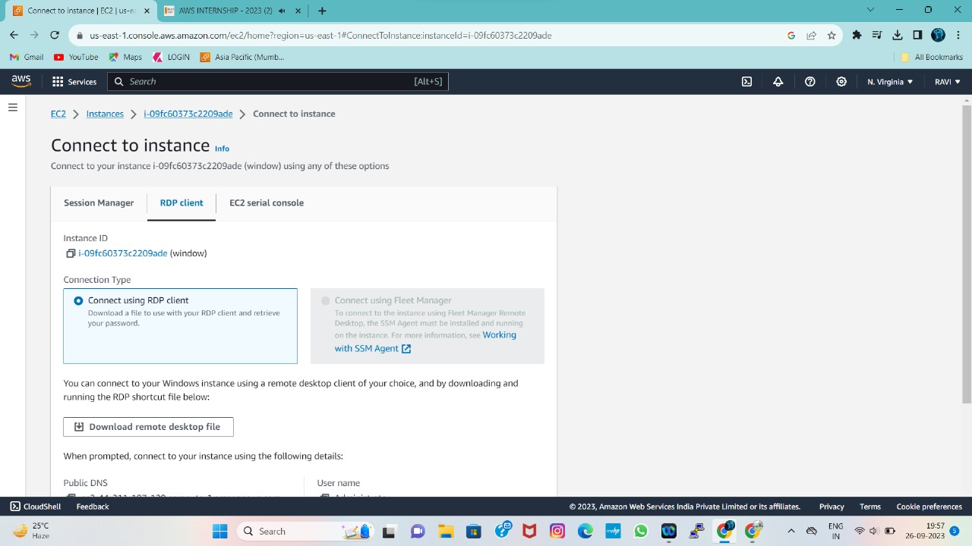

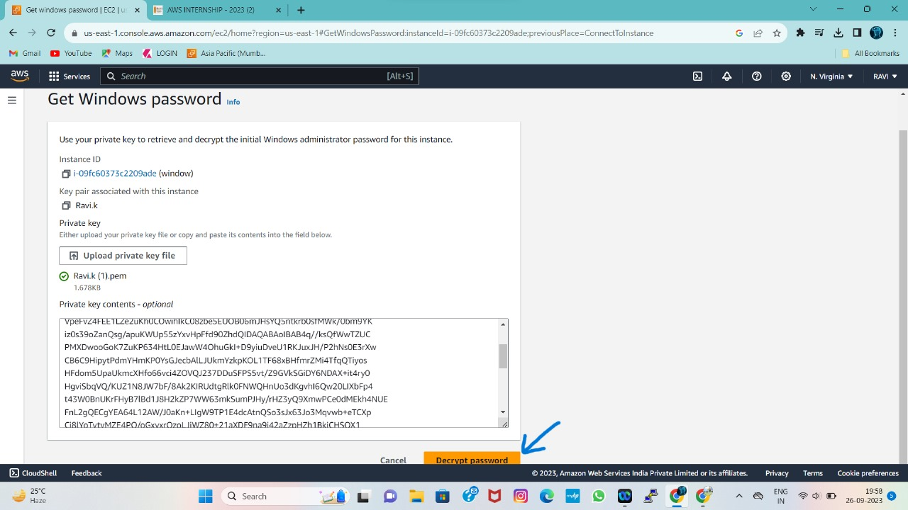

🡪Then we get user name,password,public DNS.

🡪After that we will copy all three and paste in remote desktop connection(RDP).

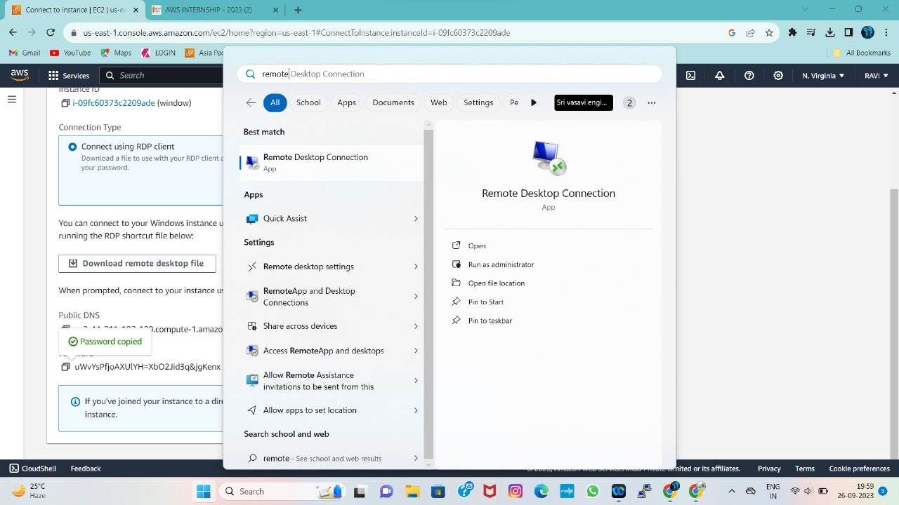

🡪After entering the all required things,then it will asks enter your decrypted password.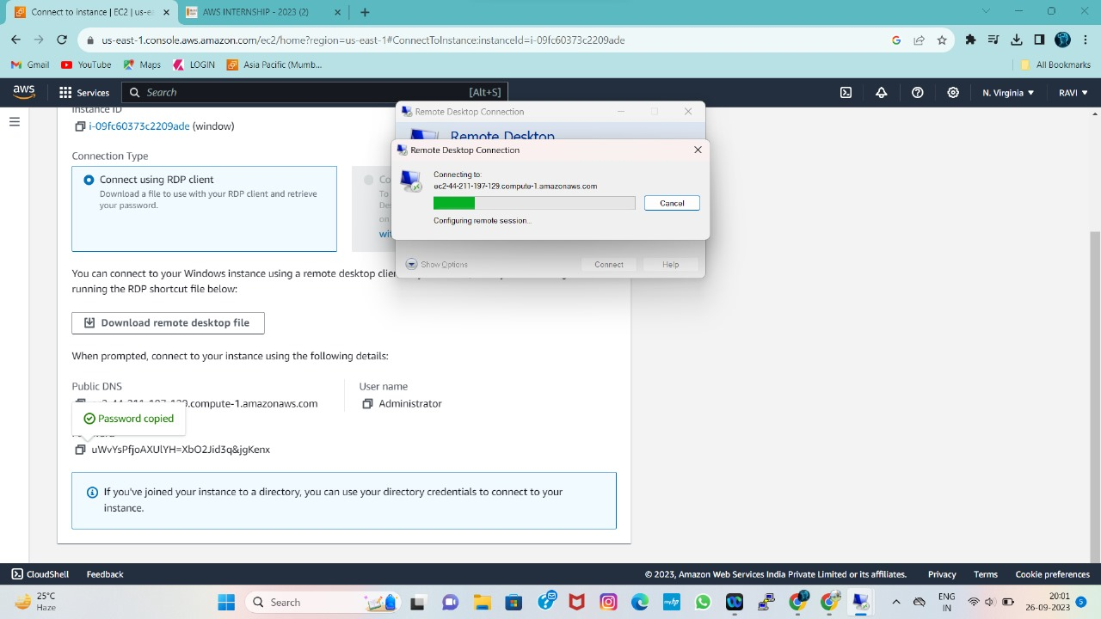🡪After above process it will ask you trust with this connection then click on yes then we will get new home screen desktop in that it will show Hostname,Instance id,Private IP,Public IP,total memory,network as show in below figure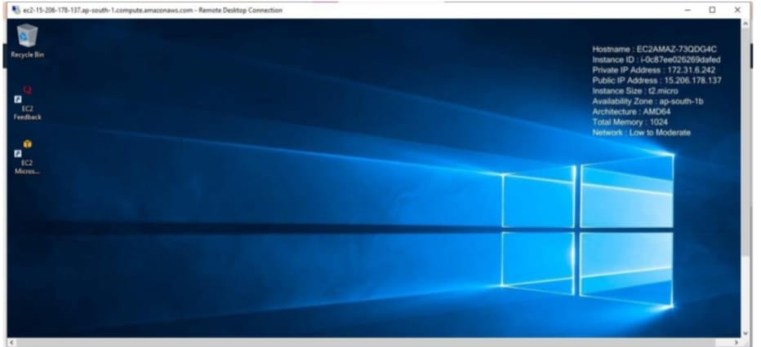

🡪After complete this process we may terminate the instance